**Installation and configuration of AutoIt**

**Installation of AutoIt:**

To install AutoIt, follow these steps:

1.Download AutoIt:

Visit the official AutoIt website at https://www.autoitscript.com/site/autoit/downloads/ and download the latest stable version of AutoIt.

2.Install AutoIt:

Run the downloaded installer.

Follow the installation wizard's instructions.

You can choose the default settings for most options during installation

3.SciTE Script Editor (Optional):

During installation, you'll have the option to install the SciTE Script Editor. It's a recommended script editor for AutoIt scripts, but it's optional.

4.Finish Installation:

Once the installation is complete, you should be able to create and run AutoIt scripts.

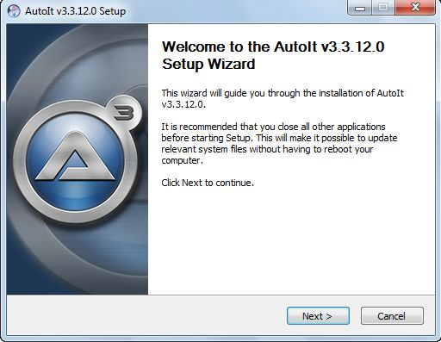

**Configuration of AutoIt:**

* Double click on autoit-v3-setup.exe file and click on **Install**.
* After successful installation, open up AutoIT Editor.

C:\Program Files(x86)\AutoIt3\SciTE

Pushing the code to GitHub repositories

* Open your command prompt and navigate to the folder where you have created your files:

Cd <folder path>

* Initialize your repository using the following command:

Git init

* Add all the files to Git repository using following command:

Git add.

* Commit the changes using the following command:

Git commit -m “add the comment”

* Push the files to the folder you initially created using the following command:

Git push -u origin master